Part 1: LEARN FROM YOUR MISTAKES!

a.If you are trying to print your name, what happens if you leave out one of the quotation marks or both, and why?

In the case of leave out one of the quotation, Python throws an SystaxError message.  
In the case of leaving out both, Python understands the input as a variable. Because this possible variable is not declared, Python throws a NameError message.

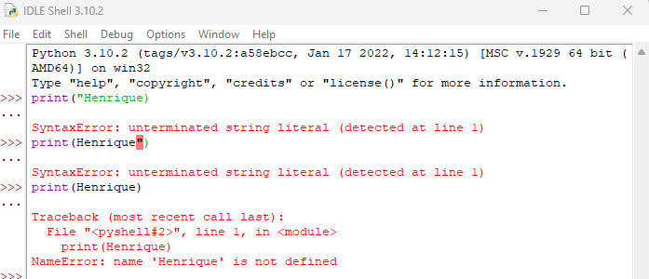

b.What is the difference between * and ** operators in Python? Explain with the help of an example.  
The * operator is responsible for multiplications, and the ** operator is responsible for exponentiation.  
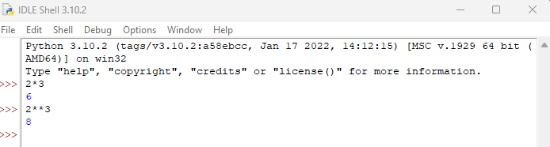

c.In Python, is it possible to display an integer like 09? Justify your answer.  
No, because it has a leading zero. If you need to display the value “09” you should pass it as a string.

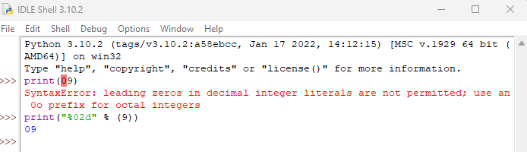

d.Run the commands type(‘67’) and type(67). What is the difference in the output and why?  
Type(‘67’) shows that the input is a string and type(67) show that the input is an integer. That happens because, although both are numbers, ‘67’ is interpreted by Python as an array of characters, and 67 as a number.  
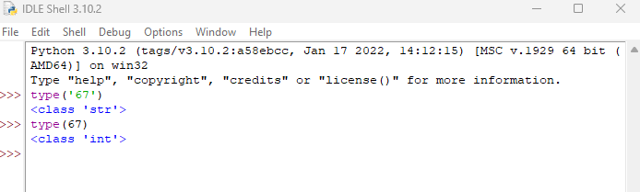

Part2:

I have created a class using the Object-Oriented Programming approach to handle the operations required for this assessment. This class named “AssessmentPart2” contains 7 properties, one to each information needed to perform each task, i.e. age, city, country, continent, startDateExam, endDateExam and temperature. I also made in this class four functions, each one responsible for the message and logic behind each task, encapsulating the rules for each message to be displayed. After instantiating the class passing the correct values, the only action needed is to call the class functions to obtain the values to be displayed. In an enterprise environment I would have made this different, but because this is not the case, hopefully this will be enough to cover what is demanded in this assessment.   
I already develop using C#, so I have decided to use this approach to handle this assessment to give me the opportunity to apply concepts that I have studied previously by myself, but using Python. I have learned with this approach: how to create properties in Python; how to create a class in Python; how to create a constructor method in Python; how to create functions in Python; how to interpolate strings in Python; what is the “self” word in Python.

REFERENCES

Object-oriented programming. (2023, September 07). In *Wikipedia*. h[ttps://en.wikipedia.org/wiki/](https://en.wikipedia.org/wiki/Object-oriented_programming)Object-oriented_programming

Component statements (2023, September 07). In *Python.* [*https://docs.python.org/3/reference/compound_stmts.html#class-definitions*](https://docs.python.org/3/reference/compound_stmts.html#class-definitions)

Defining Functions (2023, September 07). In *Python.* [*https://docs.python.org/3/*](https://docs.python.org/3/reference/compound_stmts.html#class-definitions)*tutorial/controlflow.html#defining-functions*

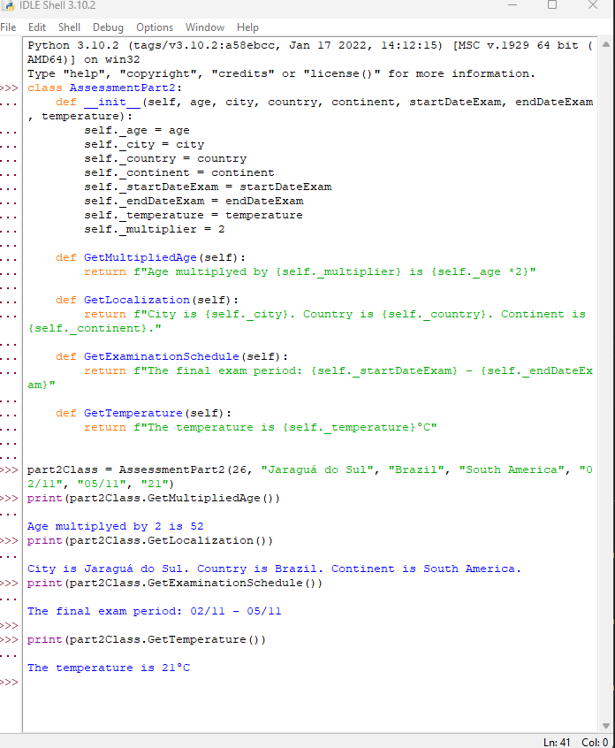

class AssessmentPart2:

def __init__(self, age, city, country, continent, startDateExam, endDateExam, temperature):

self._age = age

self._city = city

self._country = country

self._continent = continent

self._startDateExam = startDateExam

self._endDateExam = endDateExam

self._temperature = temperature

self._multiplier = 2

def GetMultipliedAge(self):

return f"Age multiplyed by {self._multiplier} is {self._age *2}"

def GetLocalization(self):

return f"City is {self._city}. Country is {self._country}. Continent is {self._continent}."

def GetExaminationSchedule(self):

return f"The final exam period: {self._startDateExam} - {self._endDateExam}"

def GetTemperature(self):

return f"The temperature is {self._temperature}°C"

part2Class = AssessmentPart2(26, "Jaraguá do Sul", "Brazil", "South America", "02/11", "05/11", "21")

print(part2Class.GetMultipliedAge())

print(part2Class.GetLocalization())

print(part2Class.GetExaminationSchedule())

print(part2Class.GetTemperature())